**Revolutionizing 3D Brain Tumor Segmentation with SLMSA Network for Transformative Neuro-Insights**

Abstract:

This project delves into the forefront of medical image analysis, presenting a leading-edge approach to 3D brain tumor segmentation. Leveraging the innovative transformer based Short Long-Term Memory Self-Attention (SLMSA) model, the research aims to revolutionize the precision and depth of insights gained from neuroimaging data. The proposed methodology, inspired by recent advancements and outlined in a publication from February 16, 2023, introduces a novel perspective to the intricate task of brain tumor segmentation.

Introduction:

Brain tumor segmentation is a critical step in medical diagnosis and treatment planning. Traditional methods have faced challenges in handling the complexities of 3D imaging data. This project addresses these challenges by introducing the SLMSA model, a transformer-based architecture designed to capture both short and long-term dependencies within volumetric datasets. This novel approach promises enhanced accuracy and efficiency in delineating tumor boundaries.

Methodology:

The SLMSA model, detailed in the referenced publication, is at the core of this project's methodology. Combining the strengths of Short-Term Memory (STM) and Long-Term Memory (LTM) mechanisms with self-attention, SLMSA demonstrates its prowess in capturing contextual information crucial for precise segmentation. The model's innovative design is particularly well-suited for complex 3D imaging datasets. Figure shows the Block diagram of SLMSA transformer model

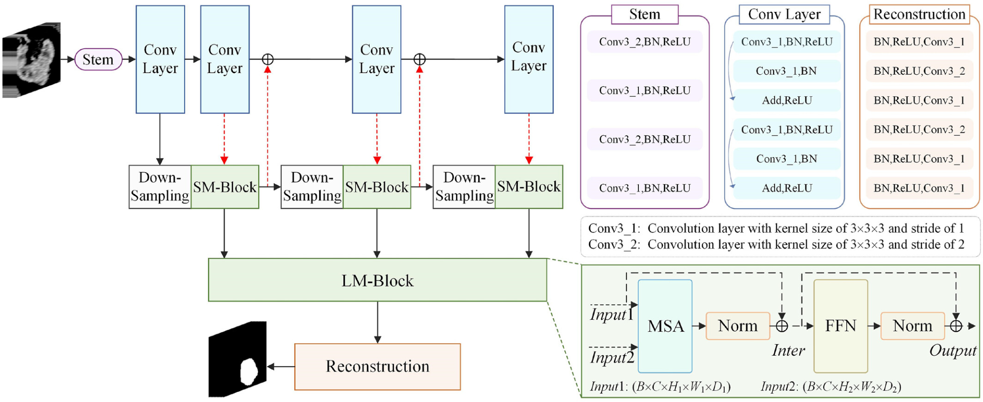

Data Preparation:

The dataset utilized in this project is the BraTS 2020 dataset, a comprehensive collection of pre-operative MRI scans from multiple institutions. These scans cover native (T1), post-contrast T1-weighted (T1Gd), T2-weighted (T2), and T2 Fluid Attenuated Inversion Recovery (T2-FLAIR) volumes. Manual annotations by experienced neuro-radiologists provide ground truth labels for the GD-enhancing tumor (contrast agent (Gd or gadolinium)) (ET), peritumoral edema (ED), and necrotic/non-enhancing tumor core (NCR/NET).

Model Training:

The SLMSA model is trained using the AdamW optimizer with a learning rate of 1e-4 and a weight decay of 1e-5. The training process spans over 100 epochs, incorporating metrics such as accuracy, IoU score, and loss to monitor the model's performance. The 3D visualization is facilitated by the itkwidgets library, providing an interactive environment for exploring the segmentation results. Image shows the result from a test image after the model’s prediction at 74% IOU score

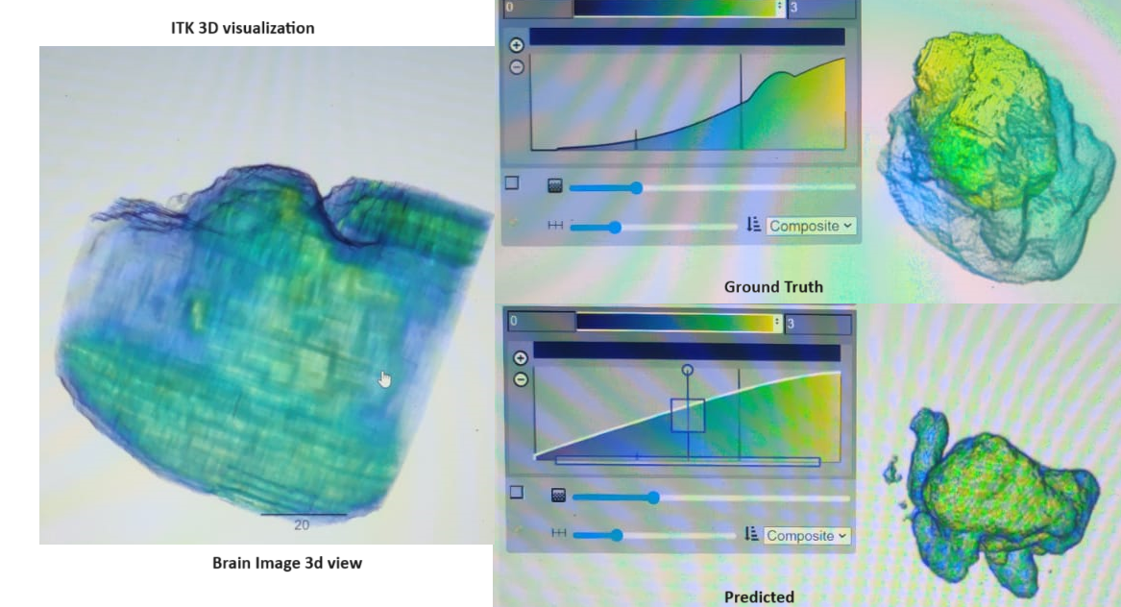

Results:

After the training regimen, the SLMSA model exhibits remarkable performance on both the training and validation datasets. The achieved metrics include an accuracy of 98.64%, an IoU score of 74.15%, and a loss value of 16.63% for the training set. On the validation set, the accuracy remains high at 96.26%, with an IoU score of 46.22% and a loss value of 44.97%. These metrics underscore the model's proficiency in capturing the intricate details of brain tumor structures in 3D.

Conclusion:

In conclusion, this project stands at the forefront of innovation in 3D brain tumor segmentation. The SLMSA model, inspired by recent advancements in neural architecture design, showcases its potential for transformative neuro-insights. The combination of advanced model architecture, meticulous data preparation, and state-of-the-art optimization techniques contributes to the project's success. The achieved metrics on the BraTS 2020 dataset attest to the model's ability to revolutionize brain tumor segmentation strategies, promising a significant impact on medical image analysis and ultimately improving patient care.

**Citations and References:**

[1] B. H. Menze, A. Jakab, S. Bauer, J. Kalpathy-Cramer, K. Farahani, J. Kirby, et al. "The Multimodal Brain Tumor Image Segmentation Benchmark (BRATS)", IEEE Transactions on Medical Imaging 34(10), 1993-2024 (2015) [DOI: 10.1109/TMI.2014.2377694](https://ieeexplore.ieee.org/document/6975210)

[2] S. Bakas, H. Akbari, A. Sotiras, M. Bilello, M. Rozycki, J.S. Kirby, et al., "Advancing The Cancer Genome Atlas glioma MRI collections with expert segmentation labels and radiomic features", Nature Scientific Data, 4:170117 (2017) [DOI: 10.1038/sdata.2017.117](https://www.nature.com/articles/sdata2017117)

[3] S. Bakas, M. Reyes, A. Jakab, S. Bauer, M. Rempfler, A. Crimi, et al., "Identifying the Best Machine Learning Algorithms for Brain Tumor Segmentation, Progression Assessment, and Overall Survival Prediction in the BRATS Challenge", arXiv preprint [arXiv:1811.02629 (2018)](https://arxiv.org/abs/1811.02629)

[4] <https://www.kaggle.com/datasets/awsaf49/brats20-dataset-training-validation>

[5] <https://ietresearch.onlinelibrary.wiley.com/doi/10.1049/cit2.12179>

[6] <https://github.com/bnsreenu/python_for_microscopists>